**ASSIGNMENT 1**

**BUILDING A SMART HOME**

**LINK:** <https://wokwi.com/projects/362725747827982337>

DIAGRAM:

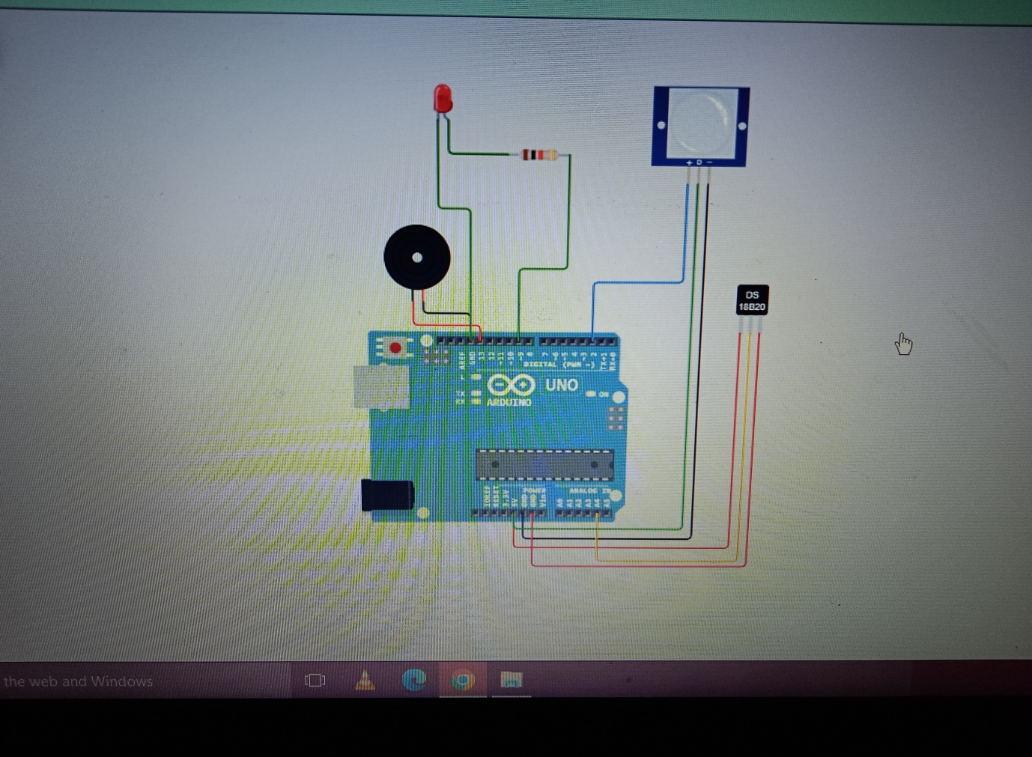

CODE:

void setup()

{

Serial.begin(9600);

pinMode(2,INPUT);

pinMode(13,OUTPUT);

}

void loop()

{

int motion=digitalRead(2);

double tempdata=analogRead(A4);

double a=tempdata/1024;

double volts=a*5;

double off =volts-0.5;

double temperature=off*100;

double deg= 50;

if (motion==1)

{

digitalWrite(13,HIGH);

delay(1000);

digitalWrite(13,HIGH);

delay(1000);

Serial.println("Motion is being detected");

}

else

{

digitalWrite(13,LOW);

Serial.println("Motion isn’t being detected");

}

if (temperature> deg)

{

digitalWrite(13,HIGH);

Serial.print("Temperature:");

Serial.println(temperature);

}

else

{

digitalWrite(13,LOW);

Serial.print("Temperature:");

Serial.println(temperature);

}

}